**Data Science Capstone**

Using Data Analysis to predict a suitable place for opening malls and complexes in Delhi

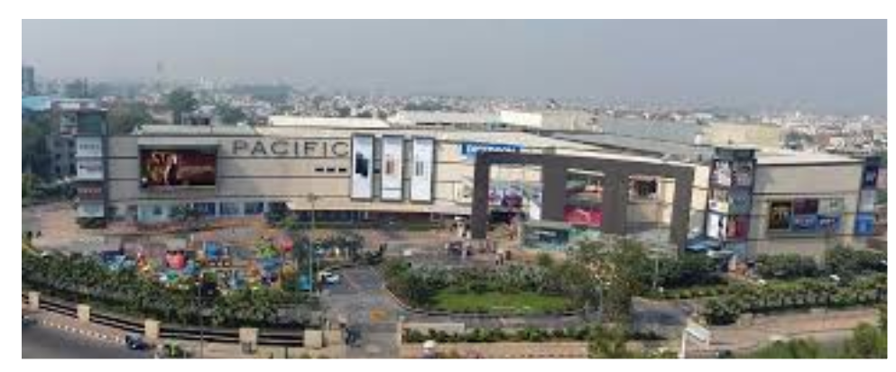

**Background**

Delhi, being the capital of India and also being the cultural hub is home to a number of businesses and Industries. NCR includes the cities which neighbour Delhi and have a lot of investment in various malls and industries. Some of the cities of NCR include Noida, Gurugram, Ghaziabad etc.

As there are endless opportunities, each and every street is filled with some shopping complex, Bars, restaurants etc.

**Business Statement**

Due to endless opportunities, a Businessman has to think about various factors including the type of business, area where the business will flourish etc. As these are the important factors which generate customers.

**Data Analysis**

The data is acquired using Foursquare API. The data analysis is done using the below factors:

* Type of Place
* Name
* Area
* City

With the help of the above information, the ideal location would be known for setting up any commercial place.